1. **Refrigerated Trucks (Reefers):**
   * Ideal for transporting perishable goods such as fresh produce, dairy products, frozen foods, pharmaceuticals, and flowers, chemicals.
   * Equipped with temperature control systems to maintain a specific temperature range.

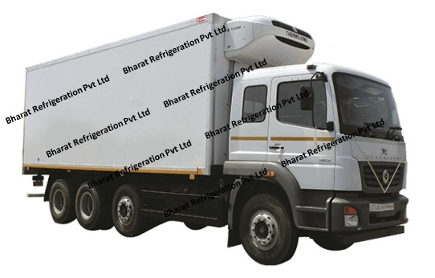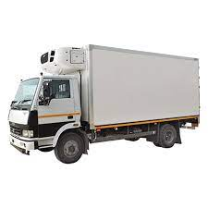

1. **Dry Vans:**
   * Suitable for a wide range of general cargo, including boxed goods, non-perishable items, and packaged goods.
   * Protects cargo from weather conditions and theft.

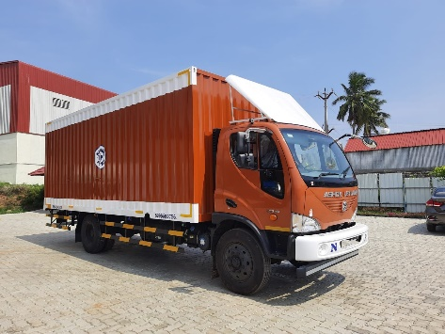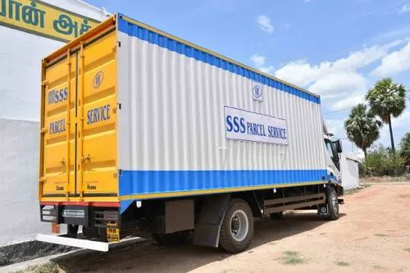

1. **Flatbed Trucks:**
   * Best for transporting large and heavy items that can be loaded and unloaded from the top or sides.
   * Ideal for construction materials, machinery, and oversized items.

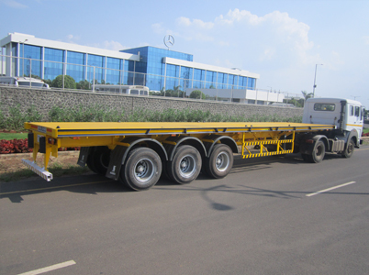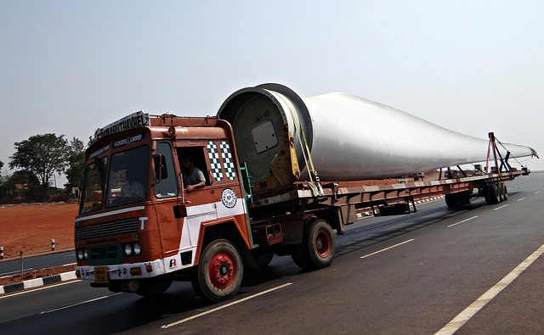

1. **Tanker Trucks:**
   * Designed for transporting liquids, including chemicals, petroleum, milk, and other liquid commodities.
   * Different types for various liquids, such as fuel tankers, chemical tankers, and food-grade tankers.

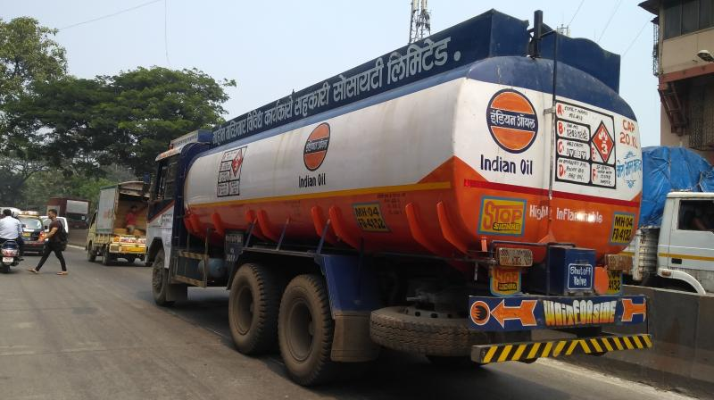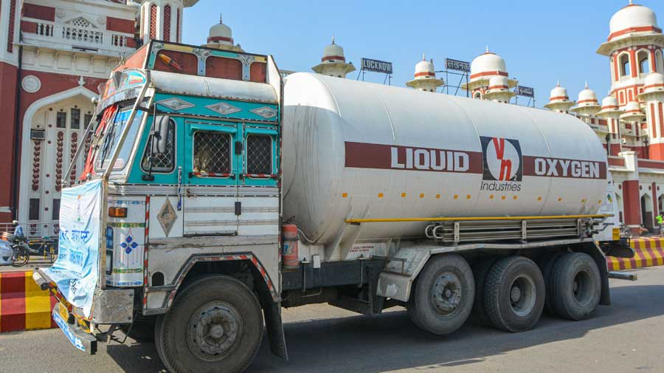

1. **Bulk Haulage Trucks:**
   * Used for transporting loose, unpackaged cargo, such as grains, coal, sand, and other bulk materials.
   * Can be open or covered.

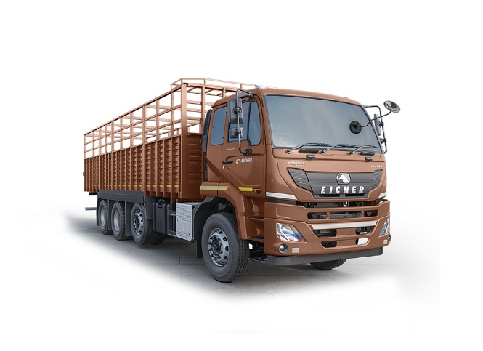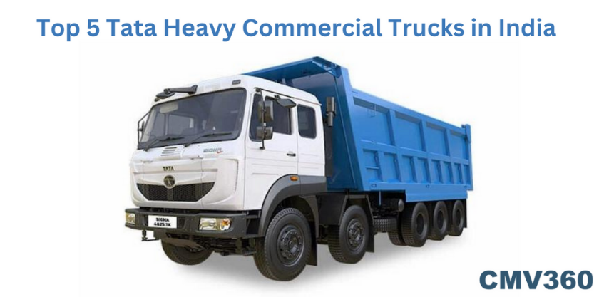

1. **Parcel Vans:**
   * Suitable for small package delivery, often used by courier and delivery services.
   * Efficient for last-mile delivery.

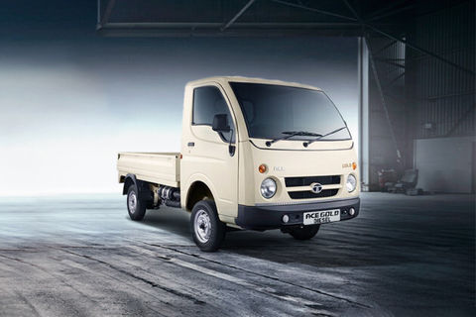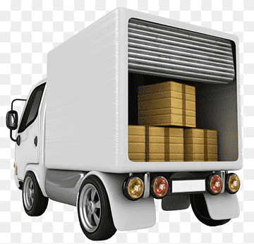

1. **Car Carriers:**
   * Specialized for transporting automobiles.
   * Designed with multiple levels to carry several cars at once.

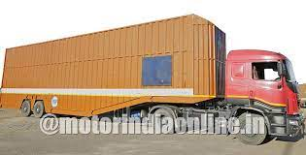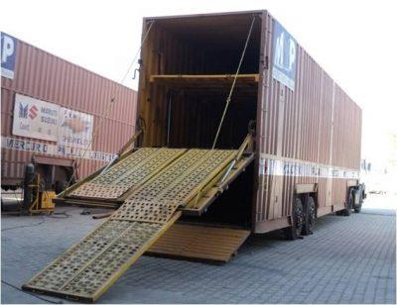

1. **Livestock Trucks:**
   * Designed for transporting live animals.
   * Equipped with facilities to ensure the safety and well-being of the animals during transport.

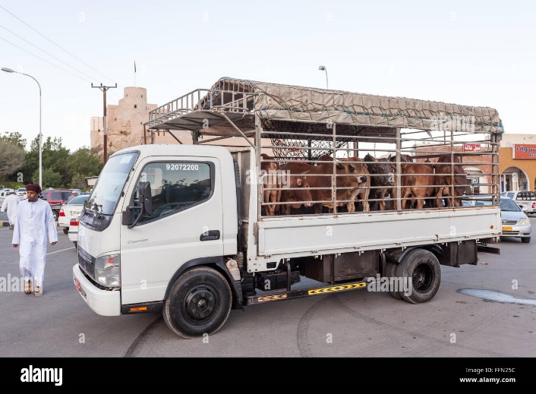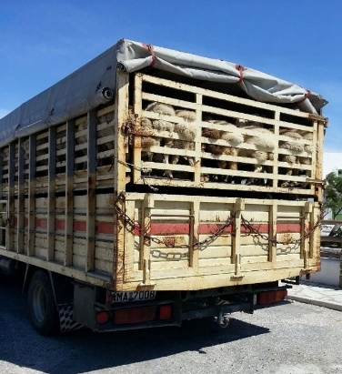

1. **Specialized Trucks:**
   * Tailored for specific industries, such as logging trucks for transporting timber, concrete mixers for construction materials, and garbage trucks for waste disposal.

